SOLO STRATEGIST

Gold
The Sovereign Survival Case
$6100/Oz
────────────────────────────────────────
A Deep-Dive on De-Dollarisation, Peak Supply, and the New Monetary Order
February 18th, 2026 | XAU/USD

SNAPSHOT
Spot Price (Feb 18, 2026) | ~$4,917 / oz
All-Time High (Jan 29, 2026) | $5,595 / oz
52-Week Range | $2,856 – $5,595
2025 Full-Year Return | +64%
YTD 2026 Return | +14%
2025 Total Demand | 5,002 tonnes (record)
Central Bank Purchases (2025) | 863 tonnes (2.5x of total British Reserves)
US M2 Money Supply | $22.4 Trillion
Solo Strategist Price Target | $6,100 / oz (year-end 2026)
Institutional Consensus Range | $5,400 – $6,300

I. THE INVESTMENT THESIS: $6,100, THE SOVEREIGN SURVIVAL CASE
Gold is no longer behaving like a commodity. It is behaving like Alternative Fiat. The historical inverse correlation between gold and real interest rates broke decisively in 2025: gold surged 64% despite elevated rates because central banks were buying for sovereign survival rather than portfolio profit. This is not a speculative thesis. It is a structural reordering of the global monetary system, and the $6,100 price target represents mean-reversion to monetary debasement, not a spike.
Our bullish case rests on four reinforcing structural pillars, each independently sufficient to support higher gold prices, and collectively pointing to $6,100 as a conservative year-end 2026 target:
1. The BRICS Gold-Backed Pivot: The launch of the BRICS ‘Unit’ creates a permanent demand floor for physical gold independent of Western retail sentiment.
2. Peak Gold Supply: Total demand exceeded 5,000 tonnes for the first time in 2025 while mine production plateaus. We are in a structural supply-demand squeeze.
3. The Debasement Catch-Up: US M2 money supply has expanded 45% since January 2020. Gold has not yet fully priced this debasement. $6,100 represents monetary fair value, not a speculative premium.
4. The AI Conductivity Moat: With $600 billion in projected AI CapEx from hyperscalers in 2026, gold’s industrial role in high-density computing infrastructure creates price-inelastic demand that most analysts overlook.
This $6,100 target aligns with Wells Fargo’s revised year-end forecast ($6,100–$6,300), J.P. Morgan ($6,300), UBS ($6,200), and Deutsche Bank ($6,000). We are not outliers. We are aligned with institutional consensus, supported by independent technical and fundamental analysis.

II. PILLAR 1: THE BRICS ‘UNIT’ AND THE GOLD-BACKED PIVOT
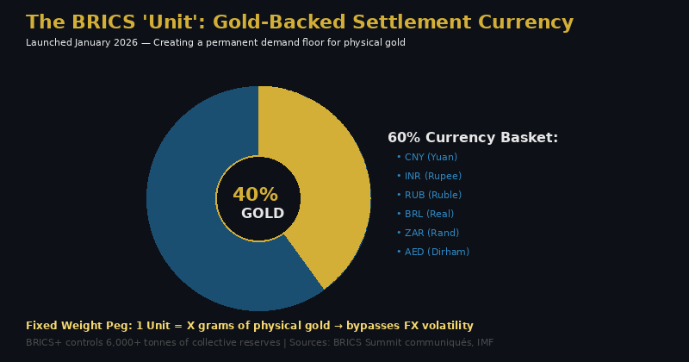
Figure 1: The BRICS ‘Unit’ — Gold-Backed Settlement Currency Architecture
While most market commentary treats ‘de-dollarisation’ as a vague geopolitical trend, 2026 has seen the emergence of a tangible competitor to dollar-denominated trade settlement. The BRICS ‘Unit’, piloted in October 2025 and formally expanded in January 2026, is a digital trade settlement instrument reportedly anchored 40% by physical gold and 60% by a basket of member currencies (yuan, rupee, ruble, real, rand, and dirham).

The Structural Demand Floor
This mechanism creates a permanent demand floor for physical gold that operates independently of Western investment sentiment or ETF flows. Unlike gold ETFs, which can see rapid outflows during risk-on rotations, sovereign settlement demand is anchored by treaty obligations and trade infrastructure. BRICS+ nations, which now include Saudi Arabia and the UAE, collectively hold over 6,000 tonnes of gold reserves and are actively adding.
China’s central bank extended its gold purchasing streak to 15 consecutive months by January 2026, with holdings reaching 74.19 million fine troy ounces valued at approximately $370 billion. Poland, the largest buyer in 2025 with 102 tonnes added, has increased its target allocation from 20% to 30% of total reserves and signalled intentions to reach 700 tonnes for ‘national security reasons.’

The Reserve Displacement Effect
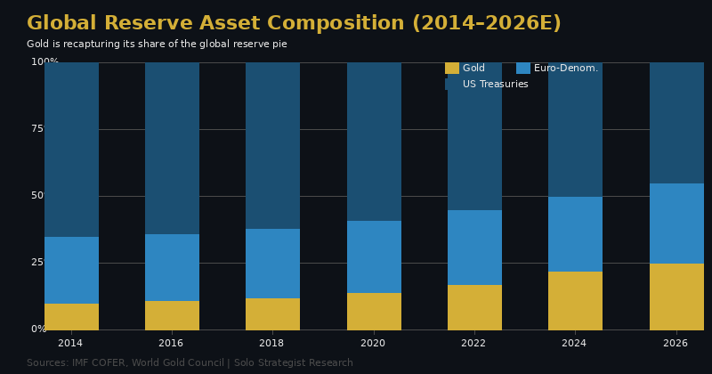
Figure 2: Global Reserve Asset Composition — Gold rising as US Treasuries decline
The dollar’s share of global foreign exchange reserves fell to 56.3% by mid-2025, a 30-year low, according to IMF COFER data. Gold’s share of total global reserves has risen from approximately 10% in 2014 to an estimated 25% by early 2026. This is not cyclical repositioning; it is structural displacement. Central bank gold purchases topped 1,000 tonnes annually in 2022, 2023, and 2024 before moderating to 863 tonnes in 2025. This is still nearly double the 400–500 tonne pre-2022 average.
The velocity of this shift is accelerating. Geopolitical friction between the US and NATO allies over Greenland has led to unexpected sell-offs of US Treasuries by European pension funds. When allies reduce their holdings of US debt, they do not rotate into Bitcoin — they rotate into gold. If even 0.5% of foreign-held US assets were redirected into gold, demand would spike sufficiently to support prices above $6,000.

III. PILLAR 2: THE SUPPLY-SIDE WALL — PEAK GOLD
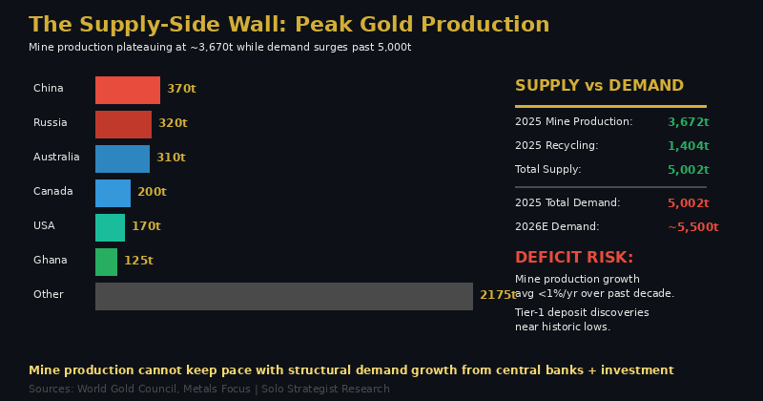
Figure 3: Peak Gold — Mine production plateauing while demand surges
The supply-demand dynamics of gold have reached a structural inflection point that most equity-focused analysts underappreciate. Total gold demand exceeded 5,000 tonnes for the first time in 2025, according to the World Gold Council, while total supply (mine production plus recycling) was essentially flat at 5,002 tonnes — a razor-thin balance that leaves no margin for demand acceleration.

Mine Production: The Plateau
Global mine production reached an estimated 3,672 tonnes in 2025 — barely surpassing the 2018 record of 3,663 tonnes after seven years of stagnation. Average annual mine production growth over the past decade has been less than 1%. The discovery of Tier-1 deposits has crashed to near-zero levels, average ore grades continue to decline, and all-in sustaining costs (AISC) rose 9% year-on-year to approximately $1,605 per ounce. The industry cannot simply ‘mine more’ to suppress prices.

Demand: The Structural Surge
Investment demand surged 84% to 2,175 tonnes in 2025, driven by global gold ETF inflows of 801 tonnes (the second-strongest year on record) and bar-and-coin demand at a 12-year high of 1,374 tonnes. Central banks added another 863 tonnes. With demand projected to approach 5,500 tonnes in 2026 and mine production unable to grow meaningfully, the physical market faces its tightest conditions in modern history.
The recycling response to the 67% price surge in 2025 was strikingly subdued — up only 3% to 1,404 tonnes. In emerging markets such as India, the Middle East, and Southeast Asia, recycling actually declined, suggesting holders expect further appreciation rather than cashing out. This behaviour reinforces the thesis that gold is being treated as a monetary asset, not a commodity.

IV. PILLAR 3: THE DEBASEMENT CATCH-UP
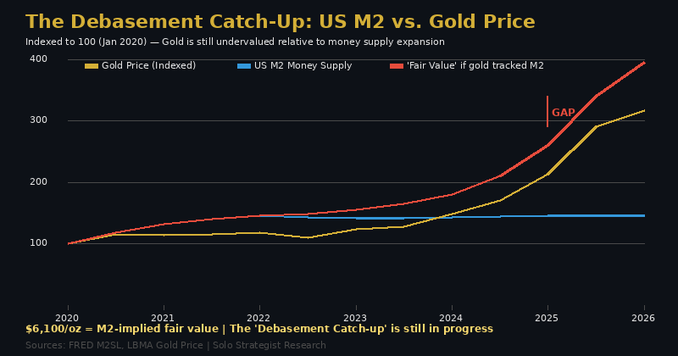
Figure 4: The Debasement Catch-Up — US M2 vs. Gold Price (indexed to Jan 2020)
The US M2 money supply has expanded from $15.4 trillion in January 2020 to approximately $22.4 trillion by December 2025 — a 45% increase representing $7 trillion in additional liquidity. Gold, despite its remarkable 2025 rally, has not yet fully priced this debasement.

The Monetary Fair Value Calculation
If gold were to track M2 money supply growth from its January 2020 base of approximately $1,550 per ounce, the implied ‘monetary fair value’ would be approximately $6,100–$6,250 per ounce. At the current spot price of approximately $4,917, gold is trading at a 20–25% discount to its M2-implied fair value. Our $6,100 target represents a catch-up to monetary reality, not a speculative premium.

The Broken Correlation
Historically, gold declined when interest rates rose. In 2025, that correlation broke decisively. Gold surged despite elevated real rates because the buyers changed. Central banks purchasing for sovereign reserve management are fundamentally different from institutional portfolio managers — they are price-insensitive, strategic buyers with multi-decade horizons. This structural shift in the buyer base means the old ‘rates up, gold down’ framework is obsolete.
If the US enters a recession in late 2026 and the Federal Reserve is forced to cut rates aggressively, the $6,100 target may represent the floor rather than the ceiling. The combination of monetary easing (lower opportunity cost for holding gold) with sustained central bank demand and supply constraints could push prices materially higher.

V. PILLAR 4: THE AI CONDUCTIVITY MOAT

Figure 5: The AI Gold Squeeze — Industrial demand in the Intelligence Age
Most analysts focus exclusively on gold as a financial asset, but its industrial role in the AI revolution is an underrated demand catalyst. Three vectors are driving incremental industrial gold demand in 2026:

Data Centre Density
AI racks consume approximately 10 times more power than traditional CPU racks. This heat and power density requires materials with zero corrosion and peak conductivity for connectors, bond wires, and thermal interfaces. Gold is becoming the ‘reliability insurance’ for $100 million-plus AI clusters. With hyperscalers guiding $600 billion or more in combined AI CapEx for 2026 (Microsoft, Alphabet, Amazon, Meta, and others), gold is price-inelastic for these buyers — they need conductivity regardless of cost.

LEO Satellite Constellations
There has been a documented surge in gold demand for High-Density Interconnect (HDI) boards used in Low Earth Orbit satellite constellations. As global satellite internet scales, the previous industry practice of ‘thrifting’ (minimising gold content to reduce costs) has been replaced by a ‘reliability first’ mandate. The harsh conditions of space require the corrosion resistance and conductivity that only gold provides.

Optical Interconnects
As AI clusters scale beyond 10,000 GPUs, copper interconnects encounter fundamental reach limitations below one metre at 224 Gbps. The transition to optical interconnects, which rely on gold-plated connectors and components, creates an entirely new demand vector that did not exist three years ago.

VI. TECHNICAL CONVERGENCE: THE $6,100 TARGET

The $6,100 price target is independently confirmed by three distinct technical and fundamental frameworks:
Technical Indicator | Target Value | Significance
Fibonacci Extension (1.618) | $6,112 | Measured from Oct 2024 lows to Jan 2026 peak ($5,595). Standard 1.618 extension.
M2 Sovereign Debt Ratio | $6,100–$6,250 | M2-implied fair value if gold tracked US money supply growth since Jan 2020.
Institutional Consensus | $6,100–$6,300 | Wells Fargo ($6,100–$6,300), J.P. Morgan ($6,300), UBS ($6,200), Deutsche Bank ($6,000).

Institutional Price Target Matrix
Institution | Year-End 2026 Target | Implied Upside | Date Issued
J.P. Morgan | $6,300 | +28% | Feb 2, 2026
UBS | $6,200 | +26% | Jan 29, 2026
Wells Fargo | $6,100–$6,300 | +24–28% | Feb 4, 2026
Deutsche Bank | $6,000 | +22% | Jan 26, 2026
Société Générale | $6,000 | +22% | Jan 26, 2026
Goldman Sachs | $5,400 | +10% | Jan 22, 2026

VII. 2026 CATALYST TIMELINE: THE $6,100 ROADMAP
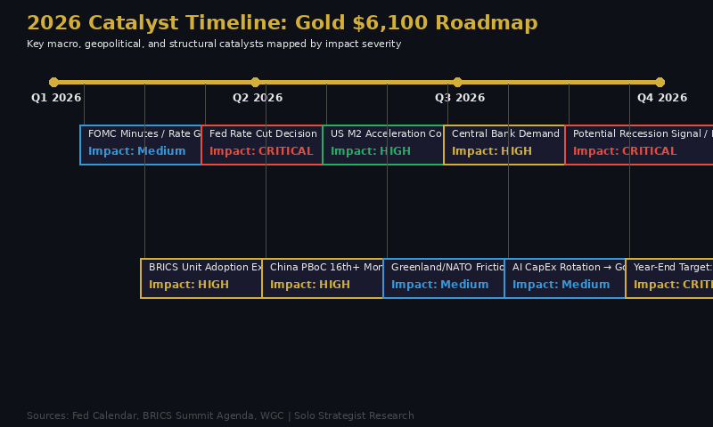
Figure 6: 2026 Catalyst Timeline mapped by origin and impact severity
Catalyst | Timing | Impact | Mechanism
Fed Rate Cut (Jun/Sep) | Q2–Q3 | CRITICAL | Lowers opportunity cost; weakens USD
BRICS Unit Expansion | Q1–Q2 | HIGH | Permanent physical gold demand floor
Central Bank Buying >800t | Ongoing | HIGH | Structural bid; price-insensitive demand
US Recession Signal | H2 2026 | CRITICAL | Aggressive Fed cuts; safe-haven flows
AI CapEx Rotation to Hedges | Q2–Q3 | MEDIUM | Tech selloff redirects capital to gold
Greenland/NATO Friction | Q1–Q2 | MEDIUM | Erodes ‘risk-free’ status of Treasuries
Fed Independence Concerns | Ongoing | HIGH | Adds $500–$800 ‘inflation regime’ premium

VIII. RISK ASSESSMENT

Value Trap Check
Verdict: Definitively not a value trap. Gold established 53 new all-time highs in 2025. Investment demand surged 84%. Central bank buying remains at historically elevated levels. The total value of global gold demand reached a record $555 billion. This is a structural bull market, not dead money.

Hype Check
Gold’s thesis is grounded in tangible, measurable dynamics: central bank reserve accumulation (863 tonnes in 2025), money supply expansion ($22.4 trillion M2), and supply constraints (mine production growth below 1% annually). If every ‘speculative’ buyer exited tomorrow, the structural central bank bid alone would support prices well above $4,000. This distinguishes gold from narrative-driven assets.

Bear Case Risks
Rapid Geopolitical Détente: If US–Iran nuclear talks, Greenland friction, and BRICS tensions all resolve simultaneously, safe-haven demand could evaporate. We assign this a low probability (15%) given the structural nature of de-dollarisation trends.
Aggressive Fed Tightening: If inflation re-accelerates and the Fed is forced into aggressive rate hikes, the opportunity cost of holding gold rises. However, the appointment of Kevin Warsh as Fed Chair may signal a more accommodative posture. Mixed probability (25%).
Speculative Unwind / Margin Calls: CME record trading volumes (3.3 million contracts on January 26) and reduced market depth mean gold is vulnerable to sharp, short-term drawdowns. The late-January correction of 21% ($5,595 to ~$4,400) demonstrated this fragility. However, each dip has been met with aggressive dip-buying, suggesting the structural bid is robust.

IX. PRICE TARGETS, ENTRY POINTS & STRATEGIC VIEW

The Solo Strategist Scenarios
Scenario | Year-End Target | Probability | Key Assumption
Bull Case | $6,800–$7,200 | 30% | Recession + aggressive rate cuts + BRICS acceleration + supply deficit
Base Case | $6,100 | 50% | Standard execution: moderate rate cuts, sustained CB buying, M2 catch-up
Bear Case | $4,200–$4,600 | 20% | Geopolitical détente + hawkish Fed + speculative unwind

Optimal Entry Points
Entry Tier | Price Range | Upside to Target | Action
Tier 1: Accumulate | $4,800–$5,200 | 17–27% | Build core position
Tier 2: Strong Buy | $4,200–$4,800 | 27–45% | Aggressive accumulation
Tier 3: Exceptional | Under $4,200 | >45% | Maximum conviction

Current Assessment (February 18, 2026): At approximately $4,917, gold sits squarely in Tier 1 territory. The metal offers approximately 24% upside to our base-case target of $6,100. The most likely catalysts for a Tier 2 or Tier 3 entry would be a speculative unwind driven by margin calls, a temporary geopolitical détente, or a hawkish Fed signal. Each of these would represent noise, not signal, and should be treated as accumulation opportunities.

SUMMARY VERDICT & STRATEGIC VIEW
Gold represents a High-Conviction Structural Position. The confluence of monetary debasement, sovereign reserve displacement, supply constraints, and industrial demand creates a structural bull case that transcends any single catalyst.

Key Data Point | Current
Spot Price (Feb 18, 2026) | ~$4,917 / oz
Solo Strategist Year-End Target | $6,100 / oz
Implied Upside | ~24%
Bull Case Year-End Target | $6,800–$7,200 / oz
Institutional Consensus Range | $5,400–$6,300
Optimal Entry (Tier 1: Accumulate) | $4,800–$5,200
Optimal Entry (Tier 2: Strong Buy) | $4,200–$4,800
2025 Total Demand | 5,002 tonnes (record)
US M2 Money Supply | $22.4 Trillion (+45% since Jan 2020)
Central Bank Purchases (2025) | 863 tonnes
Mine Production Growth (10yr avg) | <1% annually

“Gold is no longer a relic of the past. It is the infrastructure of the new monetary order. The market is still pricing the commodity whilst ignoring the currency.”

THE SOLO STRATEGIST TACTICAL VIEW
At approximately $4,917, gold offers a 24% margin to our base-case target of $6,100. Any pullback below $4,800 represents a Strong Buy entry. Periods of speculative unwinds, margin-driven corrections, or geopolitical ‘resolution’ narratives are accumulation opportunities for the disciplined, long-term allocator.



Disclaimer: This analysis is for informational purposes only and does not constitute investment advice. All data sourced from World Gold Council, IMF, Federal Reserve, LBMA, Reuters, and institutional research notes. Gold price data as of February 18, 2026.
Interested in a complementary analysis of gold mining equities or silver to pair with this macro thesis? Let us know if you would like a similar deep dive on producers like Barrick Gold, Newmont, or Agnico Eagle.

Source: Wells Fargo Investment Institute note, 4 February 2026. Previous target $4,500–$4,700.
Source: World Gold Council Central Bank Gold Reserves Survey 2025; 95% of central banks surveyed expect global gold reserves to increase.
Source: IMF COFER data, World Gold Council Annual Survey 2025. USD share of global reserves at 56.3% as of Q2 2025, a 30-year low.
Source: World Gold Council, Gold Demand Trends Full Year 2025. Total demand of 5,002 tonnes, total supply 5,002 tonnes. Investment demand +84% YoY.
Source: FRED M2SL, Federal Reserve H.6 release. M2 reached $22.4T in December 2025 vs $15.4T in January 2020.

